EBU6304 Software Engineering Group Project

2025-26
Group number | 54
member 1 | QM no: 231225339 | Name: Lechen Ning
member 2 | QM no: 231225557 | Name: Lingxiang Mei
member 3 | QM no: 231225672 | Name: Siying Li
member 4 | QM no: 231225270 | Name: Zijun Song
member 5 | QM no: 231225731 | Name: Zijie Zhang
member 6 | QM no: 231225649 | Name: Zhenkun Li

Final short report

Design
Design strategy
The system was designed as a lightweight web-based Teaching Assistant recruitment management system for BUPT International School. The design strategy was to cover the full recruitment lifecycle for three clearly separated roles: Teaching Assistant (TA), Module Organiser (MO), and Administrator (AD). Instead of adopting a heavyweight framework and relational database, the team selected a simple Java HTTP server, JSON persistence, and static HTML/JavaScript pages. This reduced setup overhead, kept the architecture transparent for academic assessment, and allowed user stories to be traced directly to interfaces, handlers, and stored data.
Architectural design
The project follows a layered client-server architecture. The presentation layer contains role-specific portals under the TA, MO, and admin directories. These pages reuse shared functions from js/api.js for authentication headers, HTTP requests, uploads, logout, notifications, status rendering, and date formatting. The service layer is a Java HTTP server started from Main.java, which exposes contexts for authentication, jobs, applications, drafts, uploads, notifications, and administrative control. The persistence layer is DataService, which stores structured records in JSON files and uploaded CV files in the uploads directory.
This structure creates a clear separation of concerns. The frontend handles navigation, forms, client-side validation, role-specific dashboards, and user-facing assistance such as local reminders and PDF preview. The backend enforces access control, validates requests, applies business rules, and returns role-scoped data. DataService centralises file I/O and session management so that individual handlers remain focused on request parsing and workflow logic. Because the frontend is also served by the same Java server, deployment stays simple and consistent across all three portals.

Implementation
Implementation strategy
Implementation was carried out incrementally around the three role workflows visible in the user manual. First, the team established the project skeleton: Java server startup, static file serving, shared API utilities, seeded JSON data, and login or registration. After that, the TA workflow was expanded to include profile management, browsing vacancies, uploading a PDF CV, saving drafts, submitting applications, tracking status, and withdrawing pending submissions. The MO workflow then added posting and editing vacancies, reviewing applicants, opening CV files, and approving or rejecting submissions. Finally, the admin workflow introduced job supervision, workload monitoring, user administration, password-reset approval, platform settings, notifications, audit logs, and summary statistics.
The technical stack was deliberately kept small and demonstrable: Java 11+ with com.sun.net.httpserver.HttpServer, Gson for JSON serialisation, and static HTML, CSS, and JavaScript pages enhanced with Tailwind CSS via CDN, Iconify icons, and ECharts for dashboards. The same implementation supports three portals available from http://localhost:8080, with separate entry pages for TA, MO, and admin users. This strategy avoided database configuration and external application-server dependencies, which made the system easier to build, test, and present within the constraints of a short group project.
Backend implementation
The backend is organised into handlers that map directly to business capabilities. AuthHandler manages login, registration, profile update, password change, and password-reset requests. JobHandler supports vacancy browsing, job creation and editing, and retrieval of job-specific applications. ApplicationHandler manages role-scoped application queries, application detail, and status transitions such as approval, rejection, and withdrawal. DraftHandler stores unfinished TA applications for later continuation, UploadHandler enforces PDF-based CV upload and download, NotificationHandler tracks user messages and read state, and AdminHandler groups system-wide functions such as user management, workload statistics, audit logs, exports, settings, and password-reset processing.
The core data models are User, Job, Application, ApplicationDraft, Notification, PasswordResetRequest, AuditLog, ExportTask, and AdminRoleTemplate. These models keep the stored JSON structure explicit and readable. For example, Application captures the applicant identity, target job, uploaded CV filename, cover letter, status, priority, AI-related advisory score, and timestamps. Job records the job type, course details, quota, weekly workload, deadline, and type-specific attributes for Course TA, Lab TA, Final Exam TA, and Class Test TA positions. This explicit modelling made it easier to map user-manual functions to concrete backend entities.
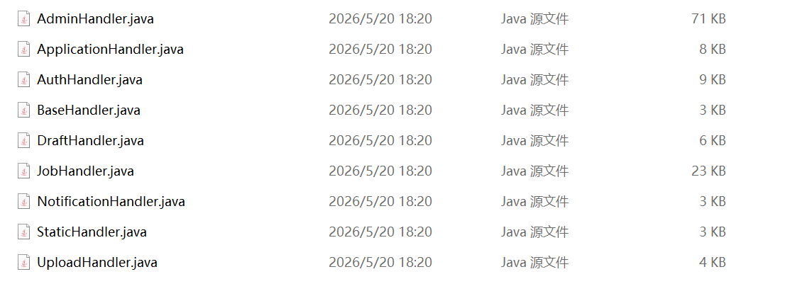  Figure 1. Backend handler classes used to separate the major business capabilities of the system. | 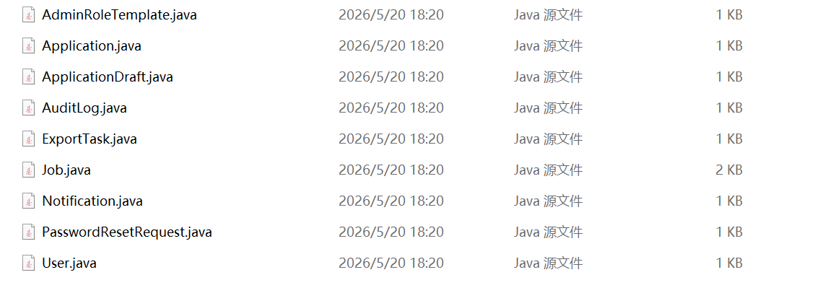  Figure 2. Core data models used for users, jobs, applications, notifications, and administration records.
These two technical views support the architectural discussion by showing how backend responsibilities are separated and how persistent entities are organised around jobs, applications, users, and administrative records.
Main.java initialises the HTTP server, prepares DataService, registers all API contexts, and starts a thread pool for request handling. DataService creates required directories, seeds demonstration users and jobs, manages in-memory session tokens, and provides synchronised JSON read or write operations. This means the request handlers do not manipulate raw files directly. As a result, backend code remains easier to test and reason about, while the stored data stays consistent across TA applications, MO decisions, notifications, and administrative records.
Authentication is token-based. After successful login or registration, the server issues a session token and the frontend stores it in localStorage, then attaches it to later requests through the Authorization header. Each handler resolves the token to a user identity and applies role checks before executing an action. For example, only TA accounts can submit or withdraw their own applications, MO accounts can manage only their own recruitment postings, and administrator-only functions protect sensitive operations such as account supervision, password resets, and audit review. This relatively simple approach is appropriate for a local academic system while still demonstrating clear access-control logic.
Frontend implementation
The frontend implementation focuses on making each role workflow direct and easy to navigate. According to the manual, the TA portal provides a dashboard, vacancy browsing, job-detail pages, application forms, AI Match advisory feedback, PDF CV upload, draft saving, and status-based application tracking. The MO portal provides job dashboards, job-posting forms, applicant lists, CV review, decision actions, and recruitment analytics. The admin portal extends this with system-wide dashboards, job supervision, workload monitoring, user management, password reset processing, settings, statistics, and audit logs. Across these pages, the interface uses consistent cards, status badges, tables, charts, and role-specific navigation so that different users can complete tasks without learning unrelated parts of the system. From an implementation viewpoint, the shared JavaScript API layer also reduces duplication across pages by standardising token handling, request submission, upload behaviour, and toast-style user feedback.
On the TA side, the interface prioritises clear progress visibility: users can enter from the dashboard, open a vacancy, complete the application form, and later review status changes from a dedicated tracking page.
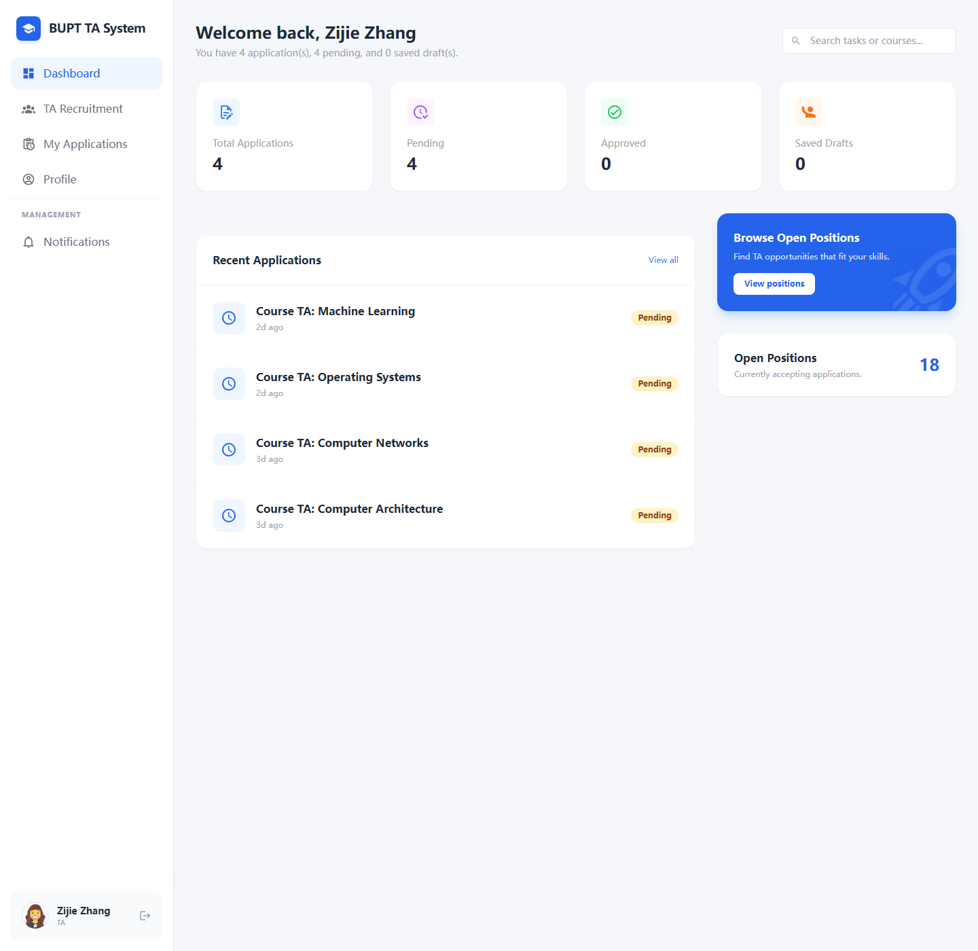  Figure 3. TA dashboard showing recent activity, navigation shortcuts, and application overview. | 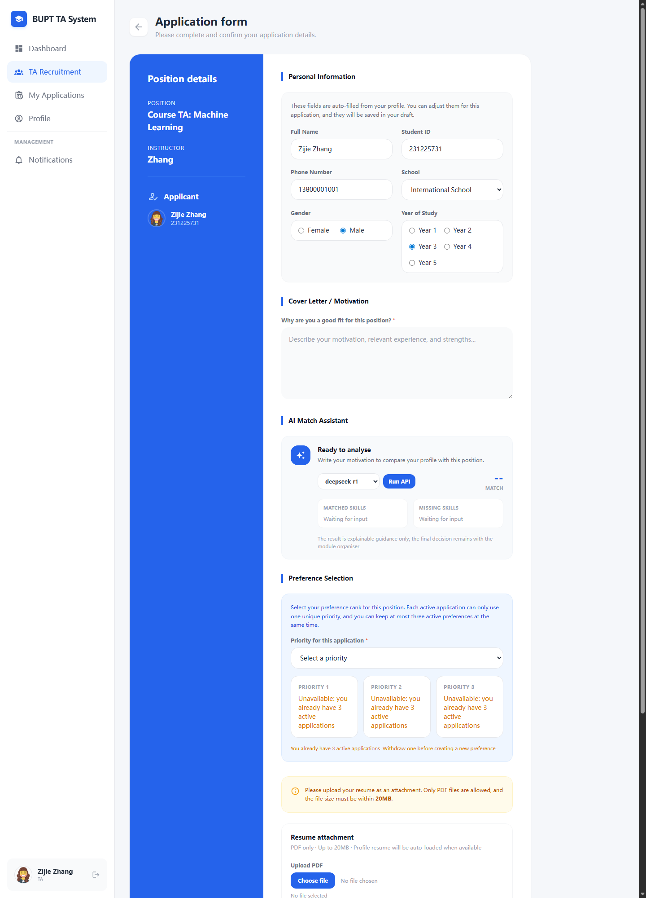  Figure 4. TA application form with profile details, motivation statement, AI Match advice, priority selection, and PDF CV upload.
Together, these TA screenshots show the applicant journey from overview to submission. They make clear that the portal is organised around progression: discovering information first, then completing a guided application workflow.
The TA submission workflow is complemented by instructor-side tools. Once a submission is made, the TA can inspect status tabs and withdraw pending records, while the MO can create new positions and control recruitment setup from a dedicated publishing form.
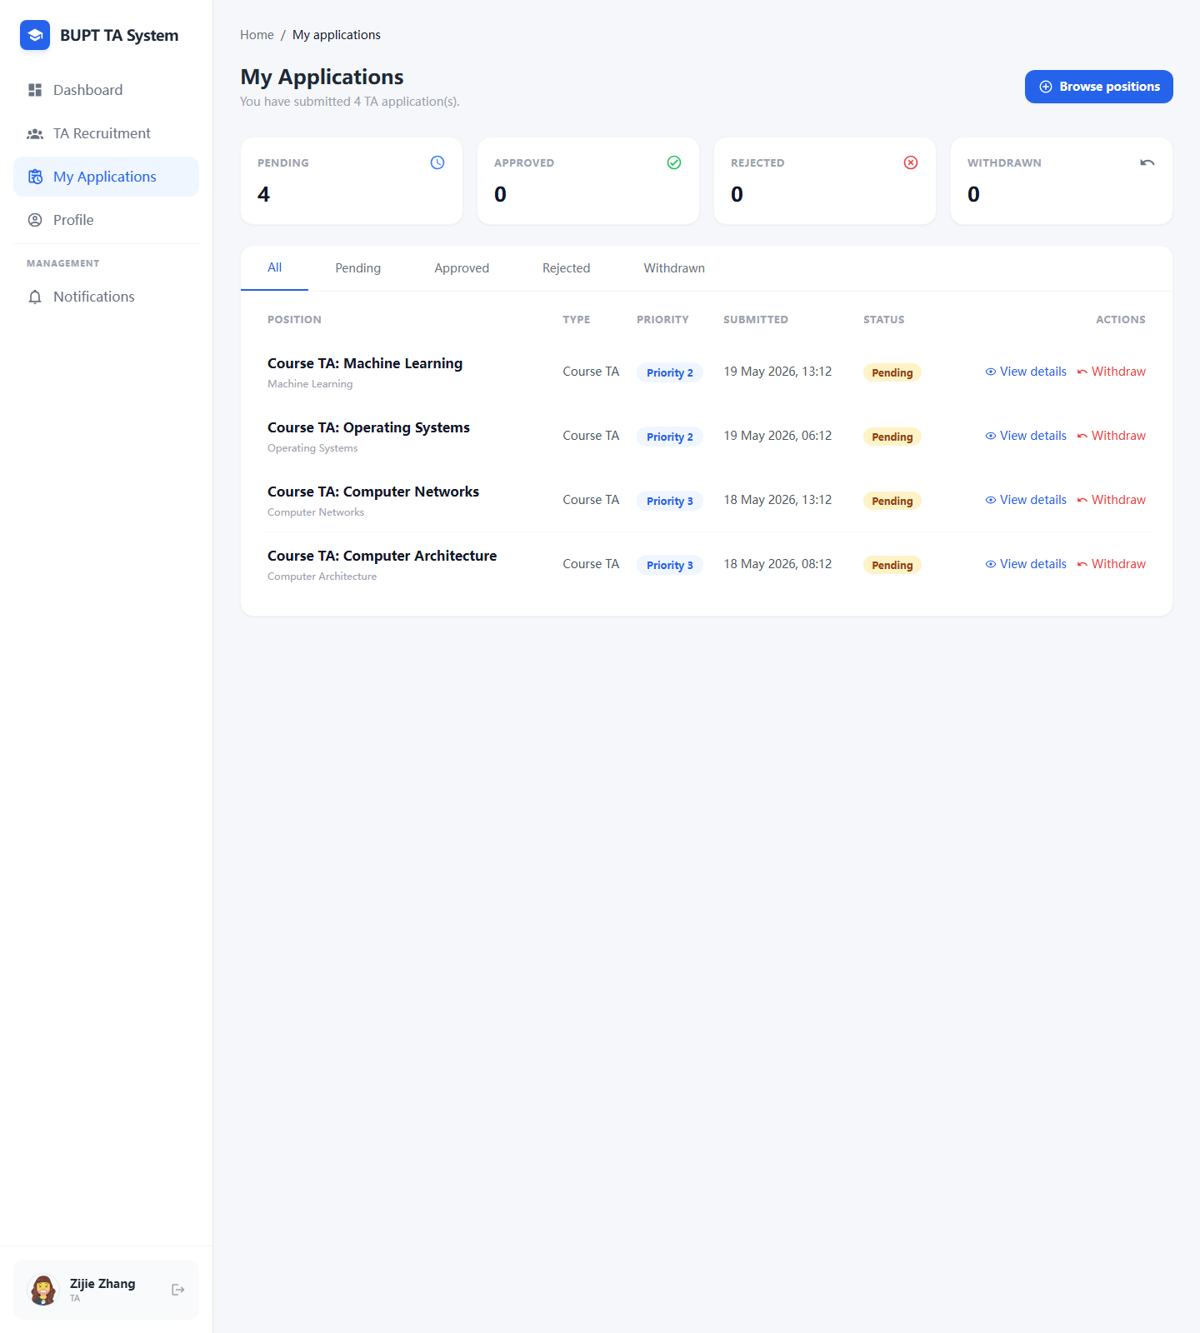  Figure 5. TA application tracking page with status tabs and withdrawal controls for pending submissions. | 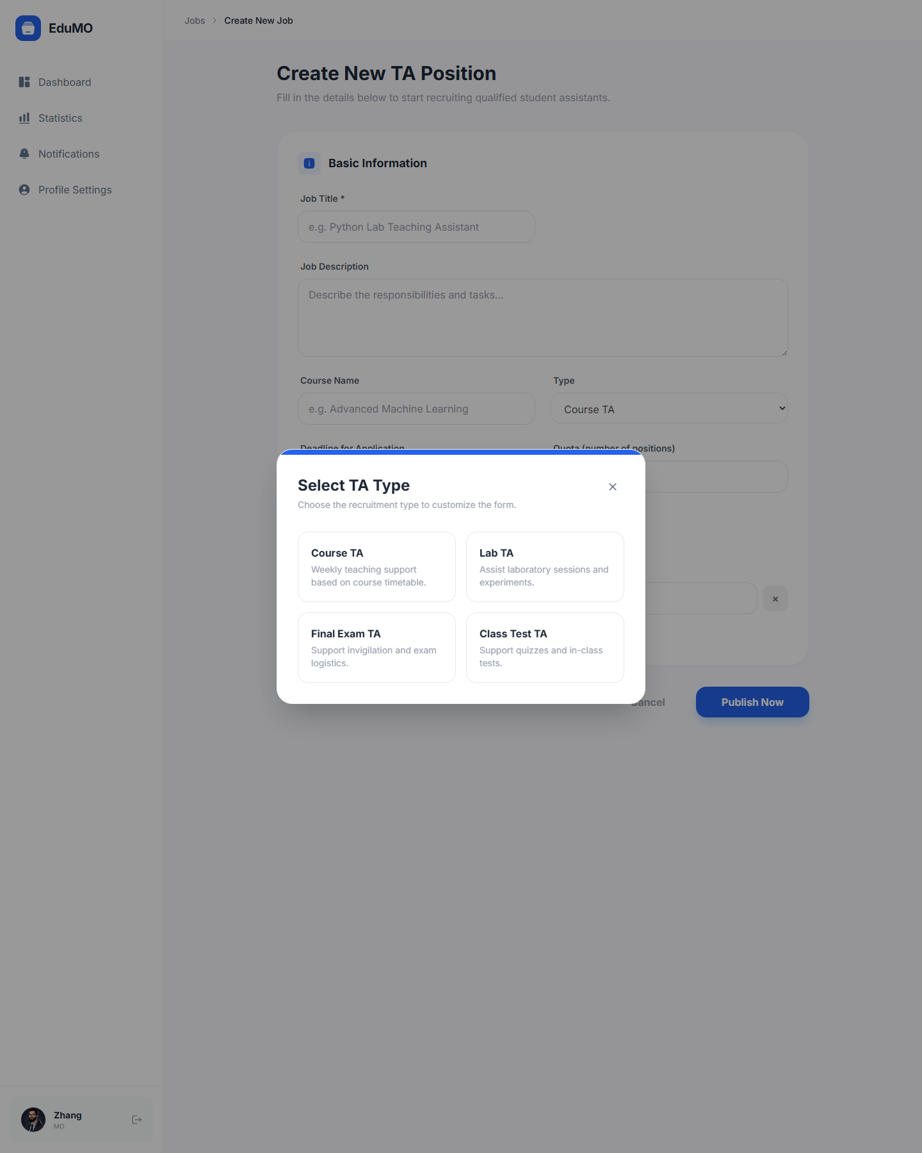  Figure 6. MO job creation interface for publishing TA recruitment posts.
This pair shows the handoff between applicant-side and instructor-side operations. The left screen focuses on post-submission tracking for students, while the right screen shows how module organisers define and publish the positions that feed that pipeline.
Recruitment analytics and administrative entry points are also surfaced visually. Module organisers can monitor recruitment progress through summary charts, while administrators authenticate into a separate governance portal.
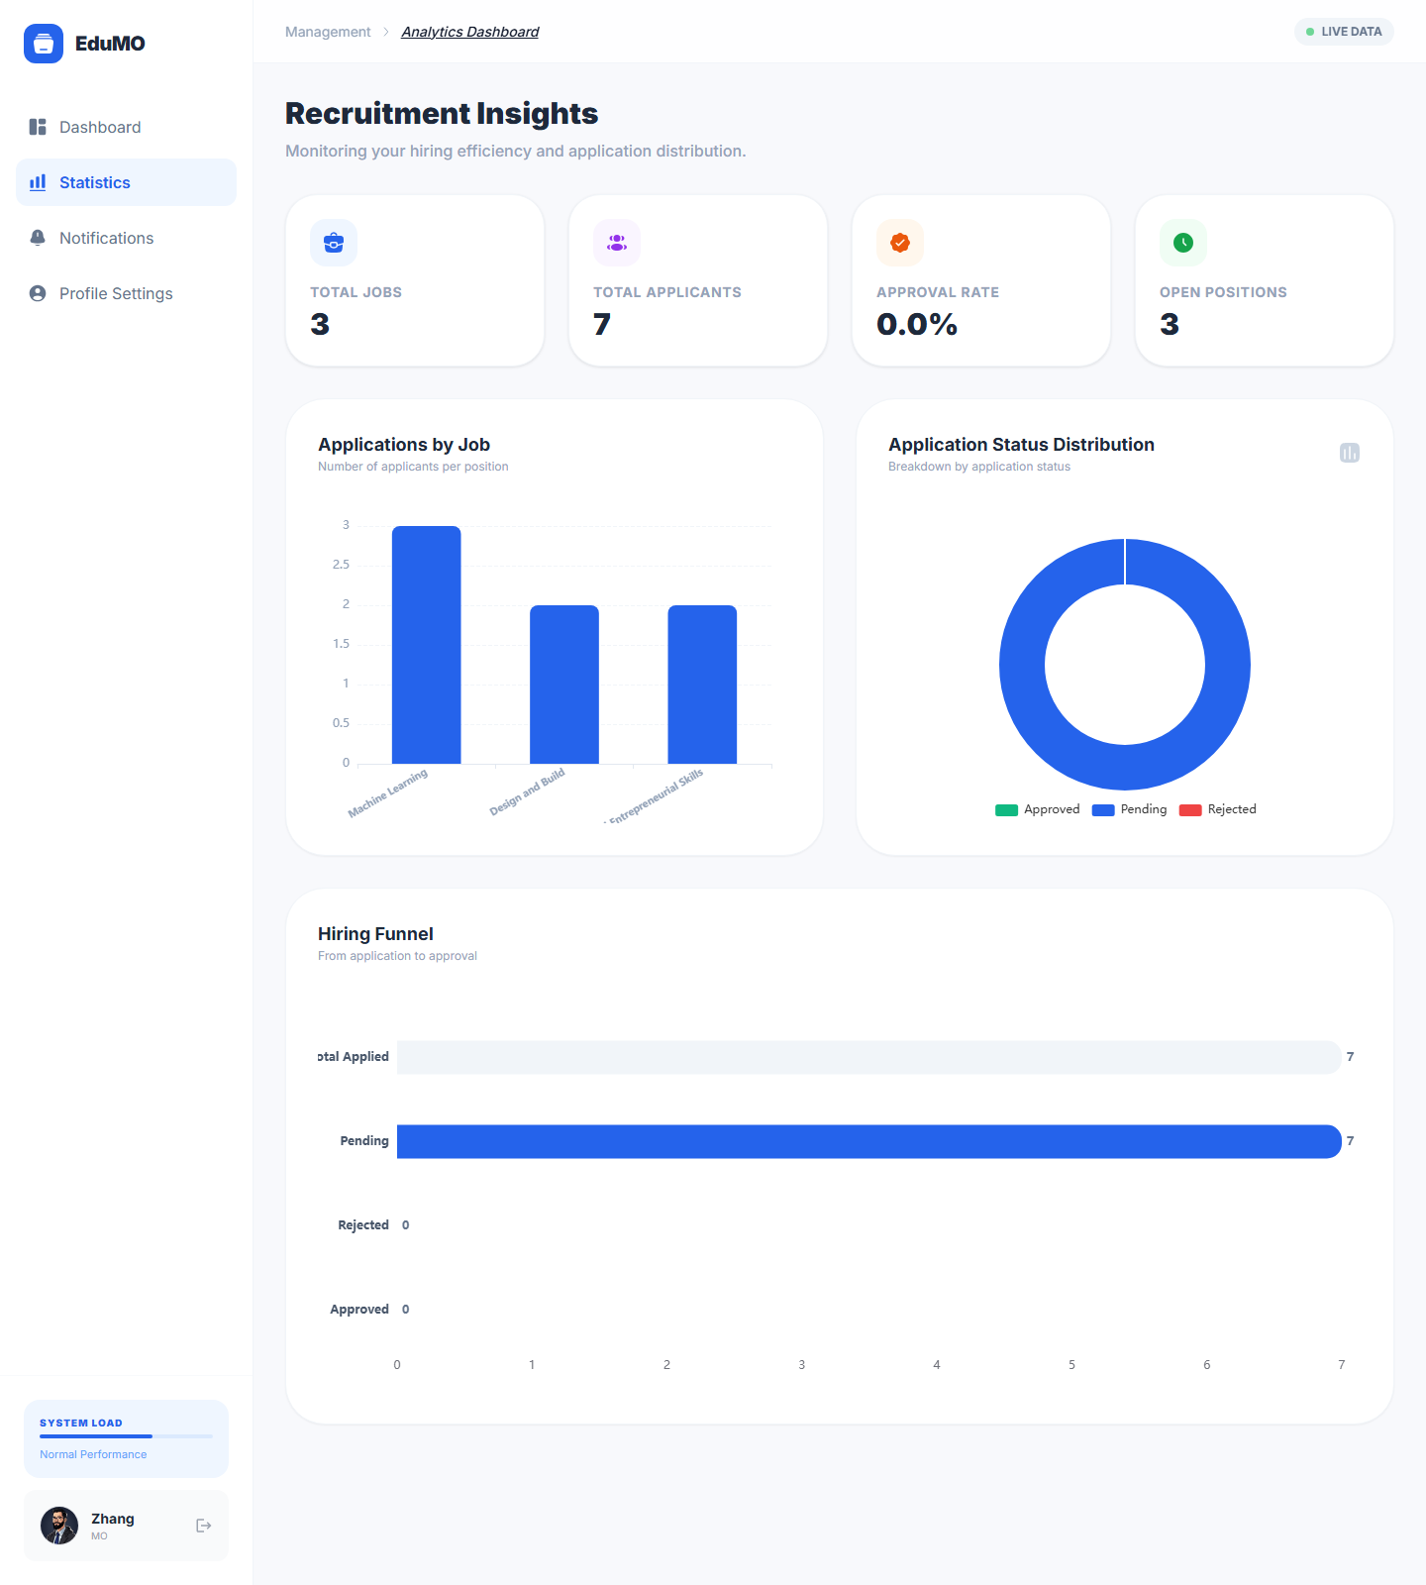  Figure 7. MO recruitment statistics page with counts, distributions, and progress charts. | 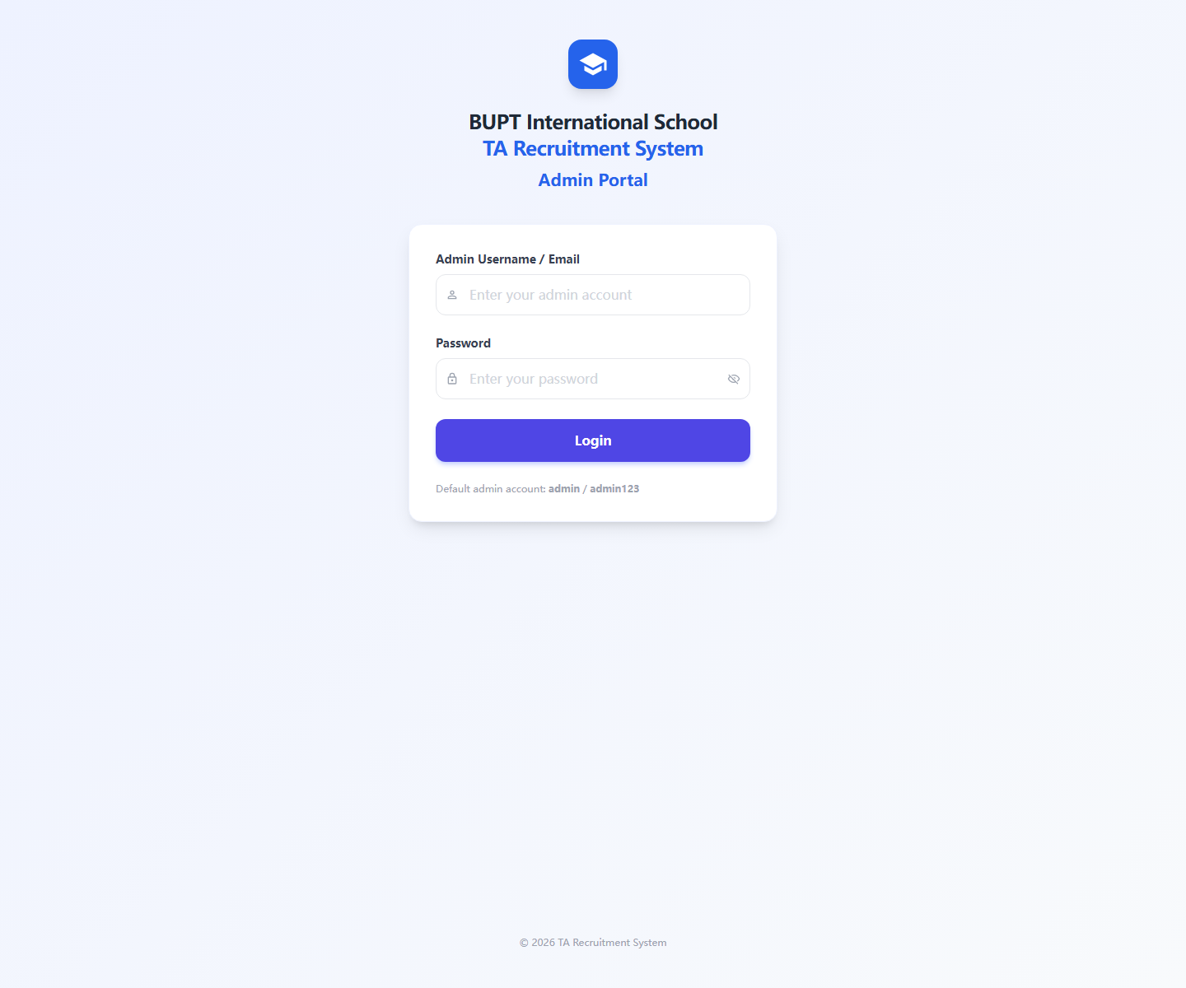  Figure 8. Administrator login page for access to system governance functions.
These interfaces support monitoring rather than data entry. The MO statistics screen summarises recruitment performance, whereas the admin login page marks the boundary between ordinary teaching workflows and privileged governance operations.
Within the administrator portal, the most important operational screens combine high-level monitoring with sensitive approval actions. The dashboard concentrates system-wide alerts and activity summaries, while the password reset page supports supervised account recovery.
For completeness, the report also captures the main entry and browsing screens used before application submission. These pages show how TA users authenticate and scan open vacancies before moving into the detailed application workflow.
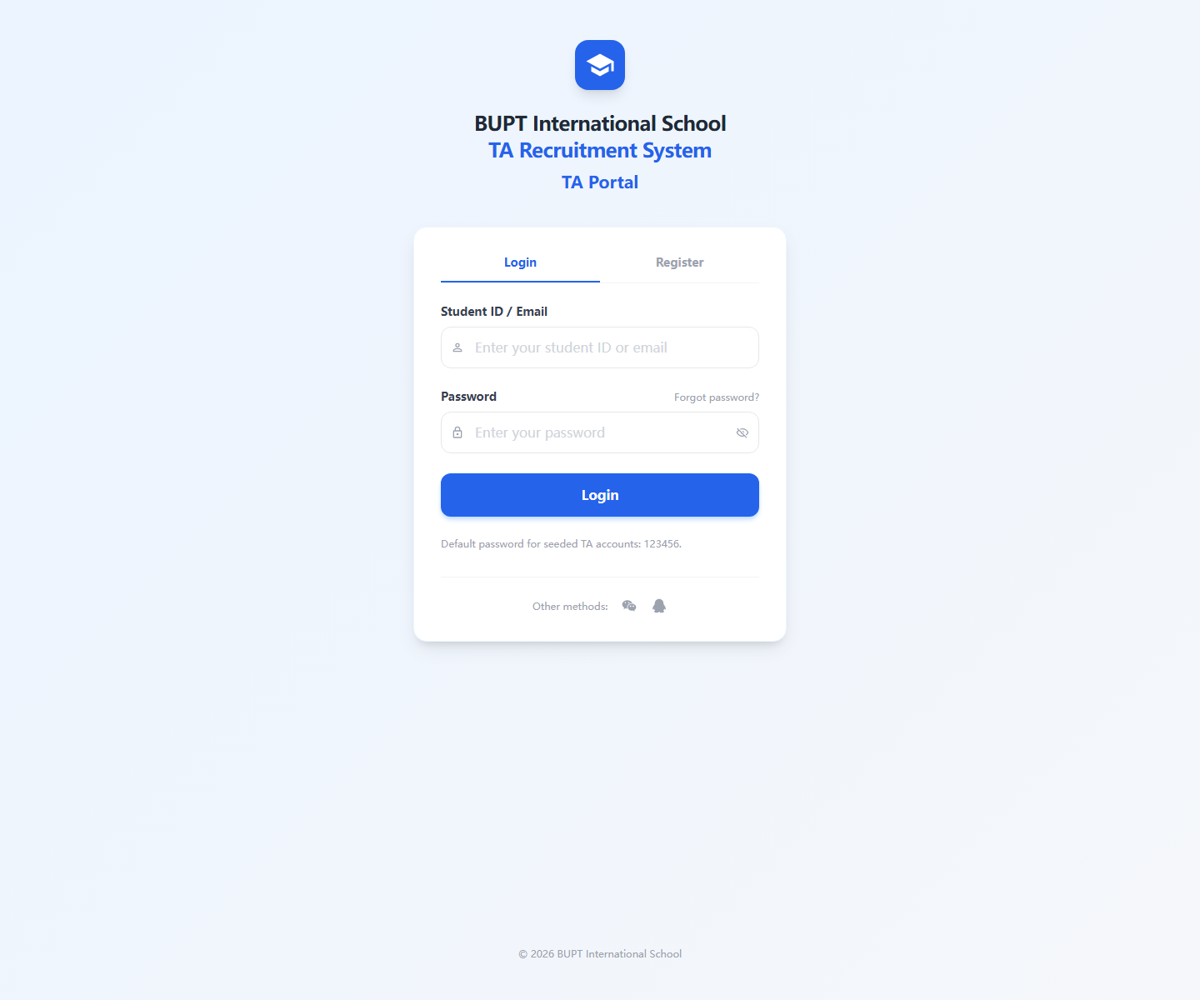  Figure 9. TA login page used for applicant authentication and password recovery entry. | 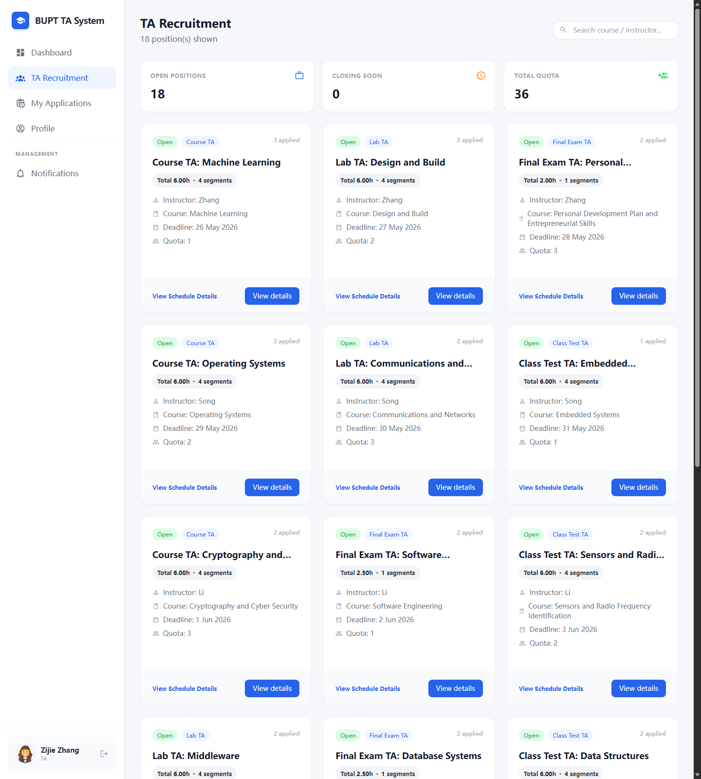  Figure 10. TA vacancy browsing page showing available positions, quotas, deadlines, and workload summaries.
These screenshots capture the very start of the TA experience. Before any application is submitted, users must authenticate successfully and compare openings using deadline, quota, and workload information presented in the vacancy list.
The MO workflow also includes separate entry and management screens beyond the post-creation page already shown above. These interfaces support day-to-day recruitment administration and detailed review of applicants and attachments.
Beyond the core TA flow, the report next presents the remaining MO and Admin pages needed to show full functional coverage across all three roles.
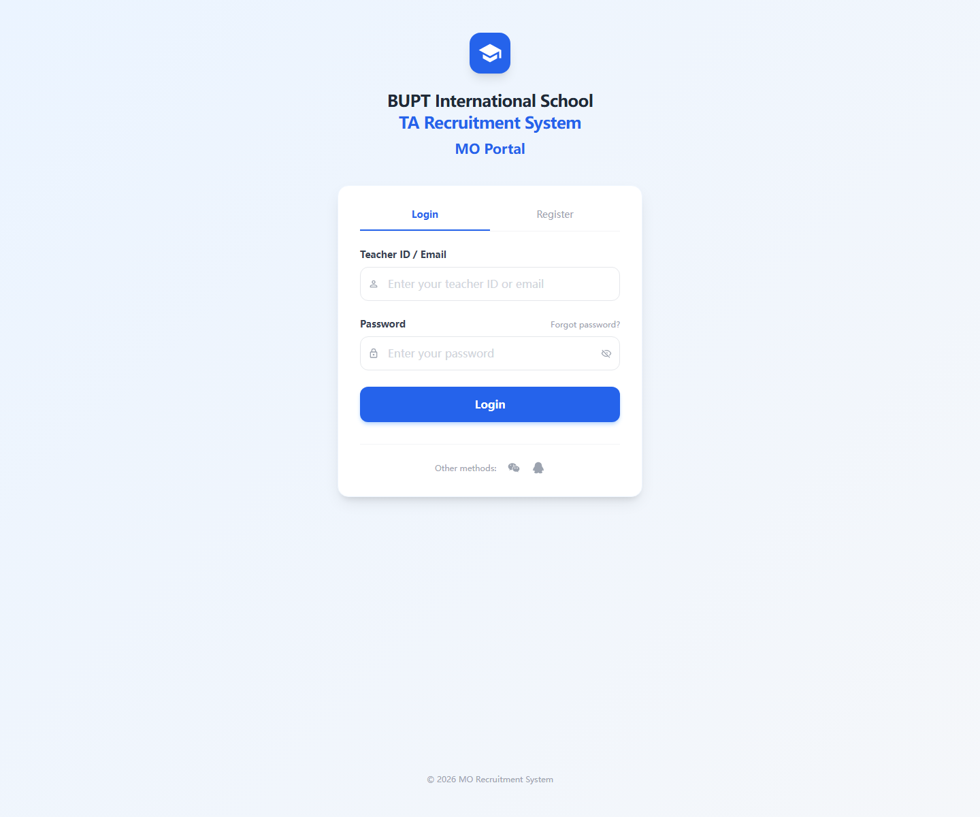  Figure 11. MO login page for instructor-side access to recruitment management functions. | 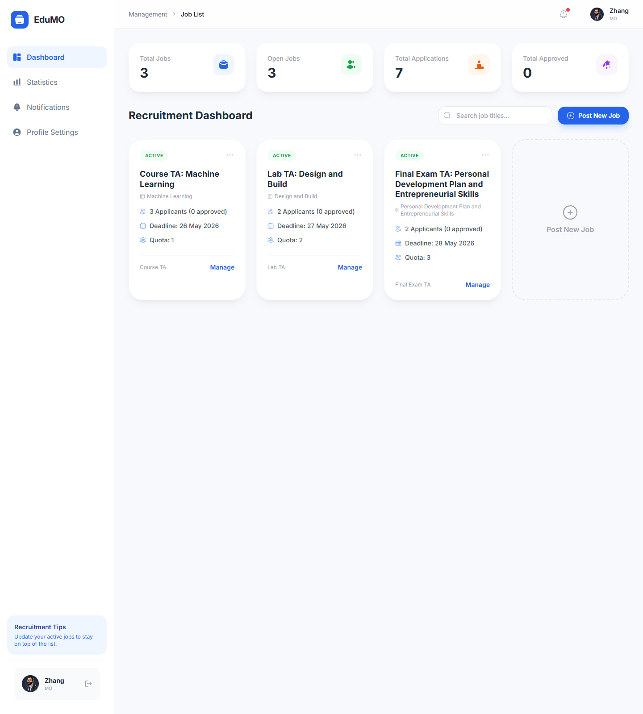  Figure 12. MO recruitment list page for managing published vacancies and opening job-specific controls.
The MO portal is not limited to posting new roles. It also provides a dedicated landing page and a management-oriented recruitment list so that instructors can return to active vacancies and coordinate later decisions efficiently.
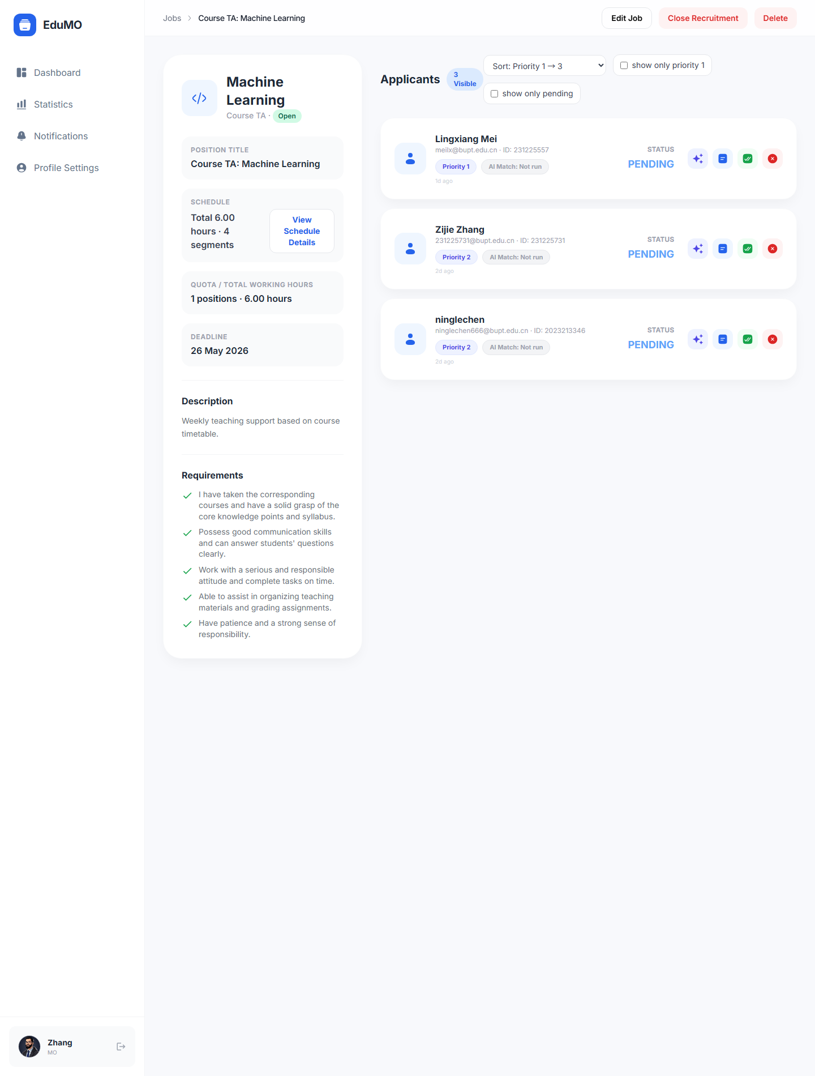  Figure 13. MO applicant review page for inspecting candidate details, CV files, and approval decisions. | 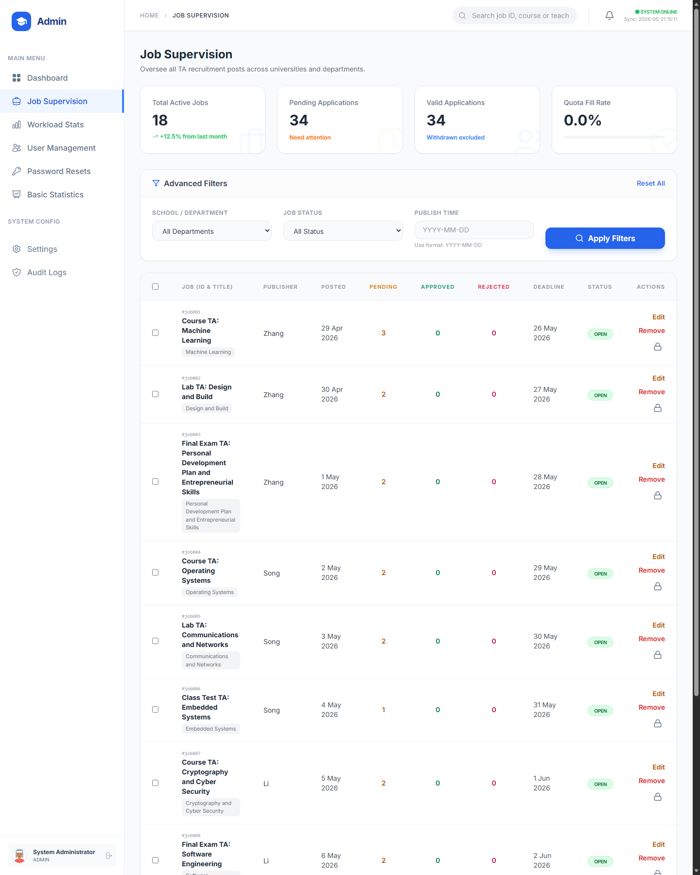  Figure 14. Admin job supervision page for cross-department vacancy oversight and intervention.
This pair shows the transition from instructor-side recruitment management to institution-wide supervision. Applicant review remains role-specific for the MO, while job supervision broadens the scope to cross-department administrative oversight.
On the administrative side, the remaining operational pages focus on balancing workload, supervising accounts, and maintaining traceable platform-wide control over settings and system activity.
The following administrator screens move from recruitment oversight into platform governance, where workload, users, statistics, settings, and auditability become the central concerns.
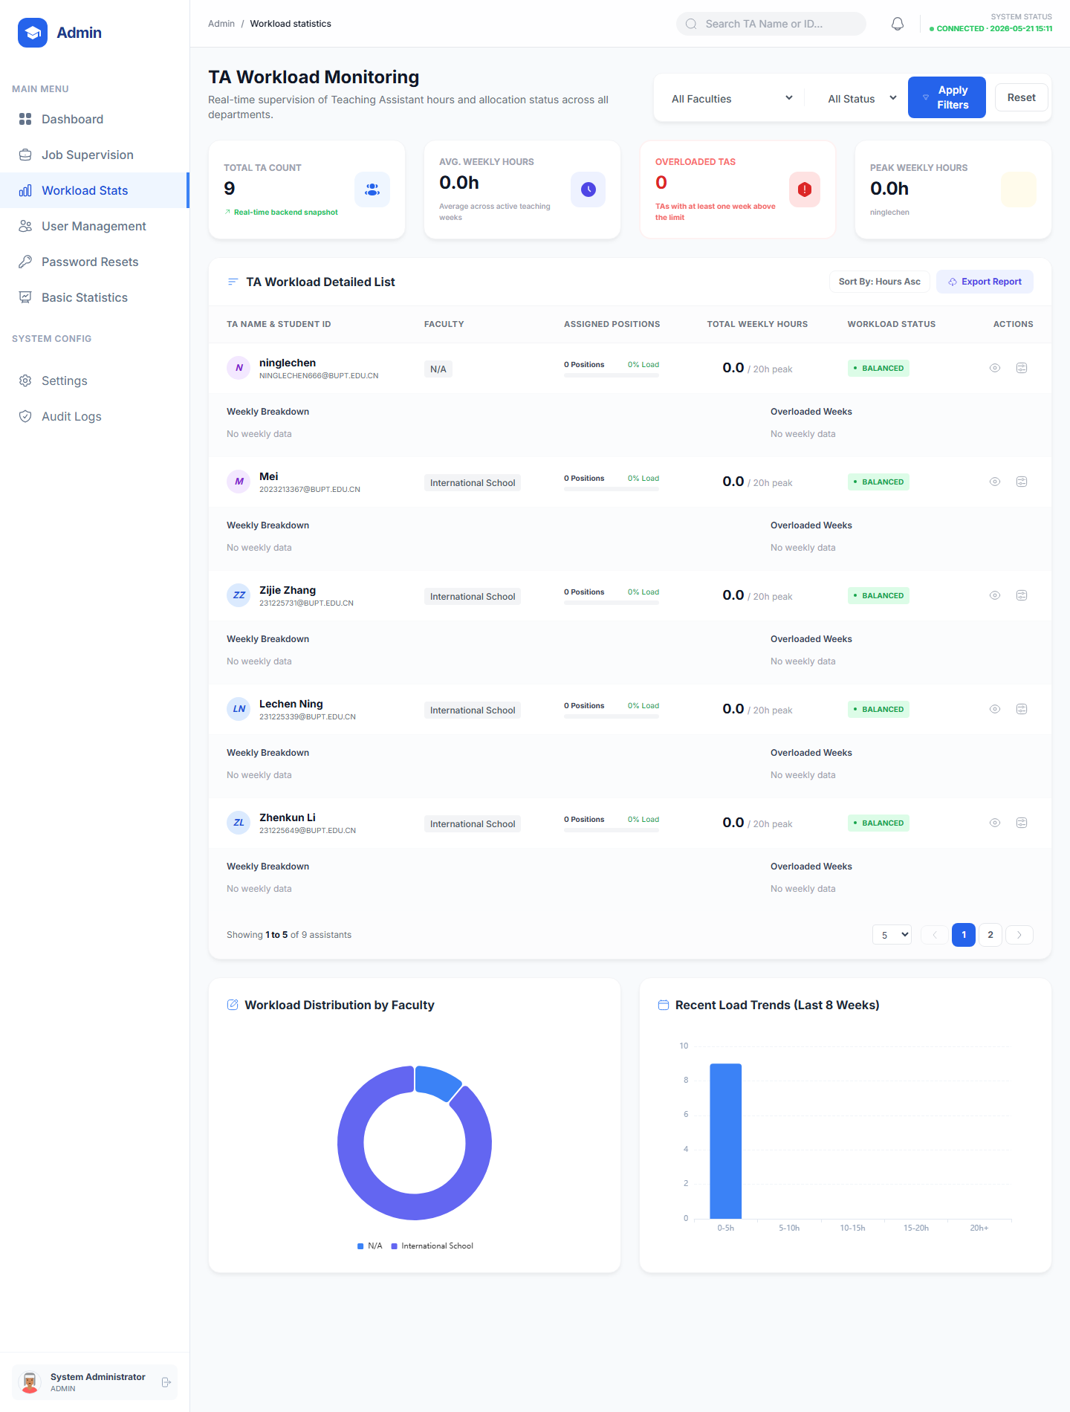  Figure 15. Admin workload monitoring page showing TA allocation, peak hours, and overload risk indicators. | 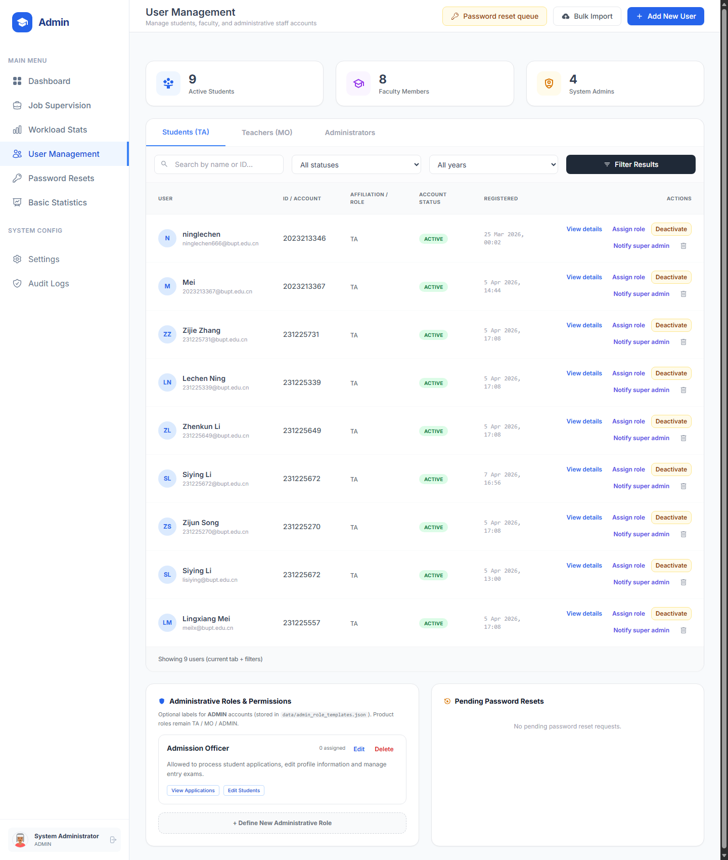  Figure 16. Admin user management page for supervising TA, MO, and administrator accounts.
These pages focus on operational control of people rather than individual vacancies. One emphasises workload balance and overload detection, and the other centralises account review, role switching, and user-status management.
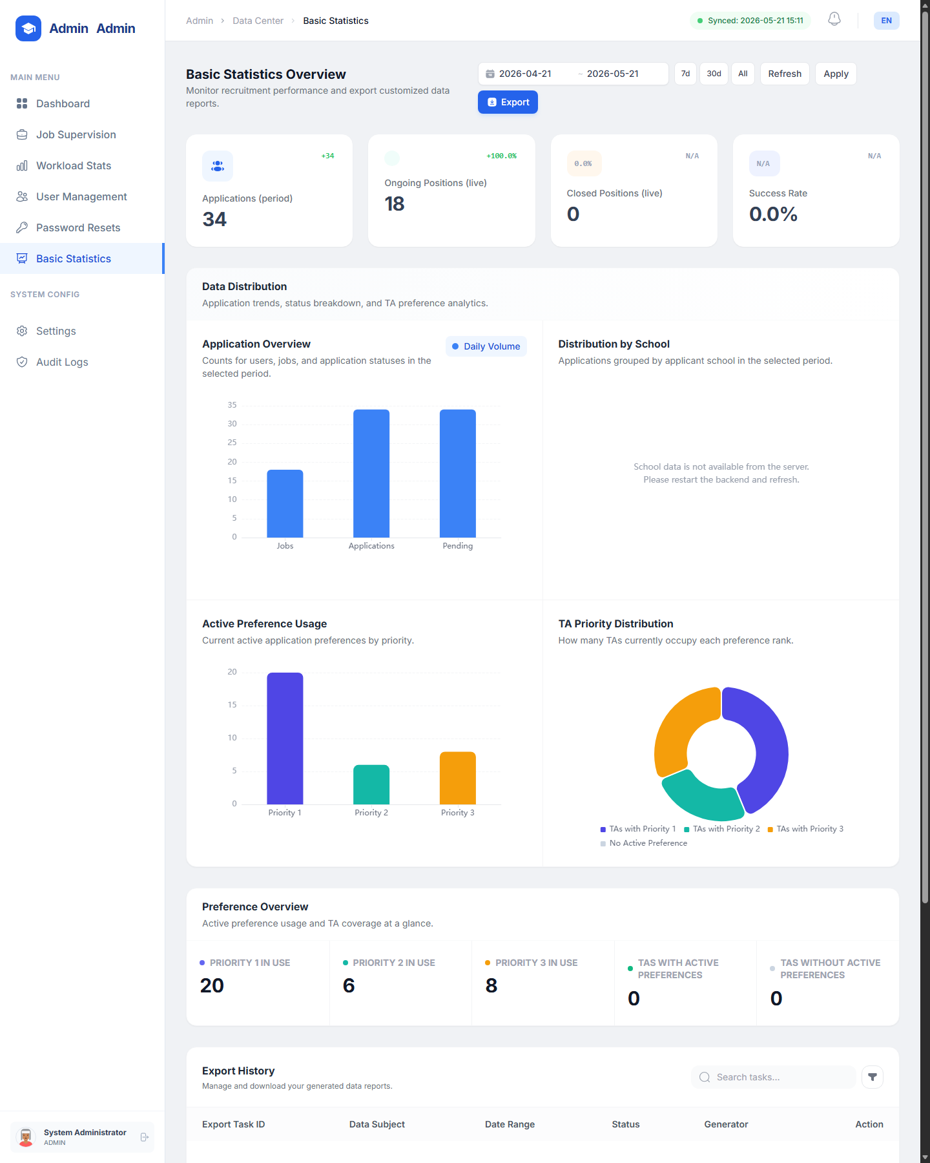  Figure 17. Admin basic statistics page for summary indicators, chart-based reporting, and export-oriented review. | 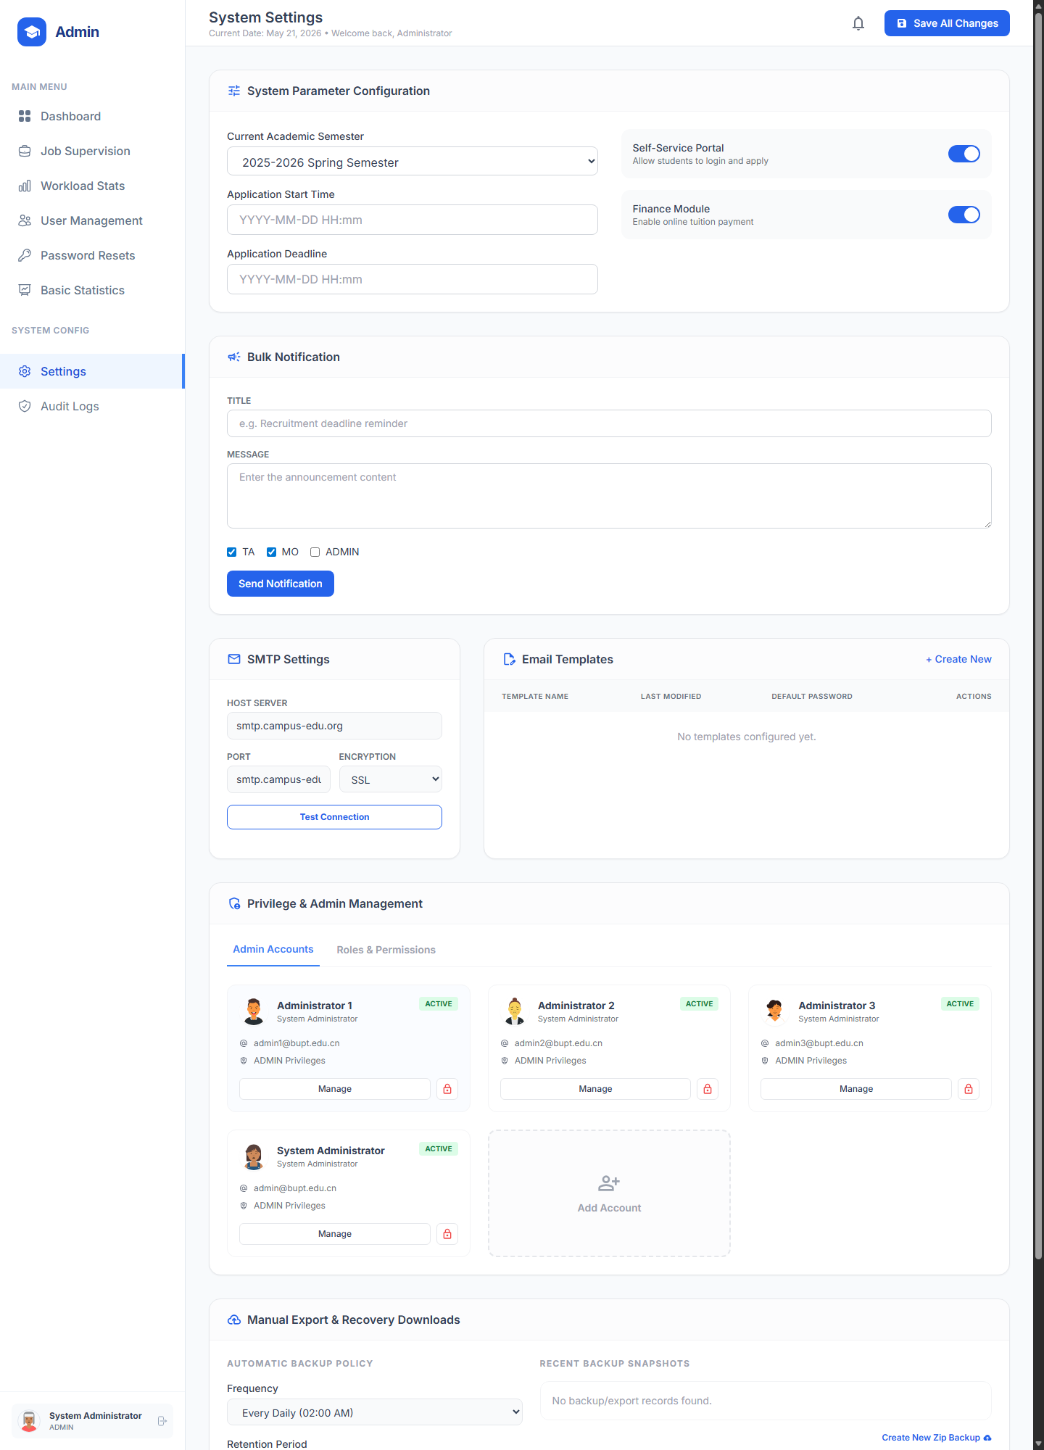  Figure 18. Admin settings page for platform configuration, messaging, privileges, and recovery-related controls.
At this point the administrator workflow becomes more platform-oriented. Summary statistics support reporting and export, while the settings page exposes the controls required to tune messaging, permissions, and high-level system behaviour.
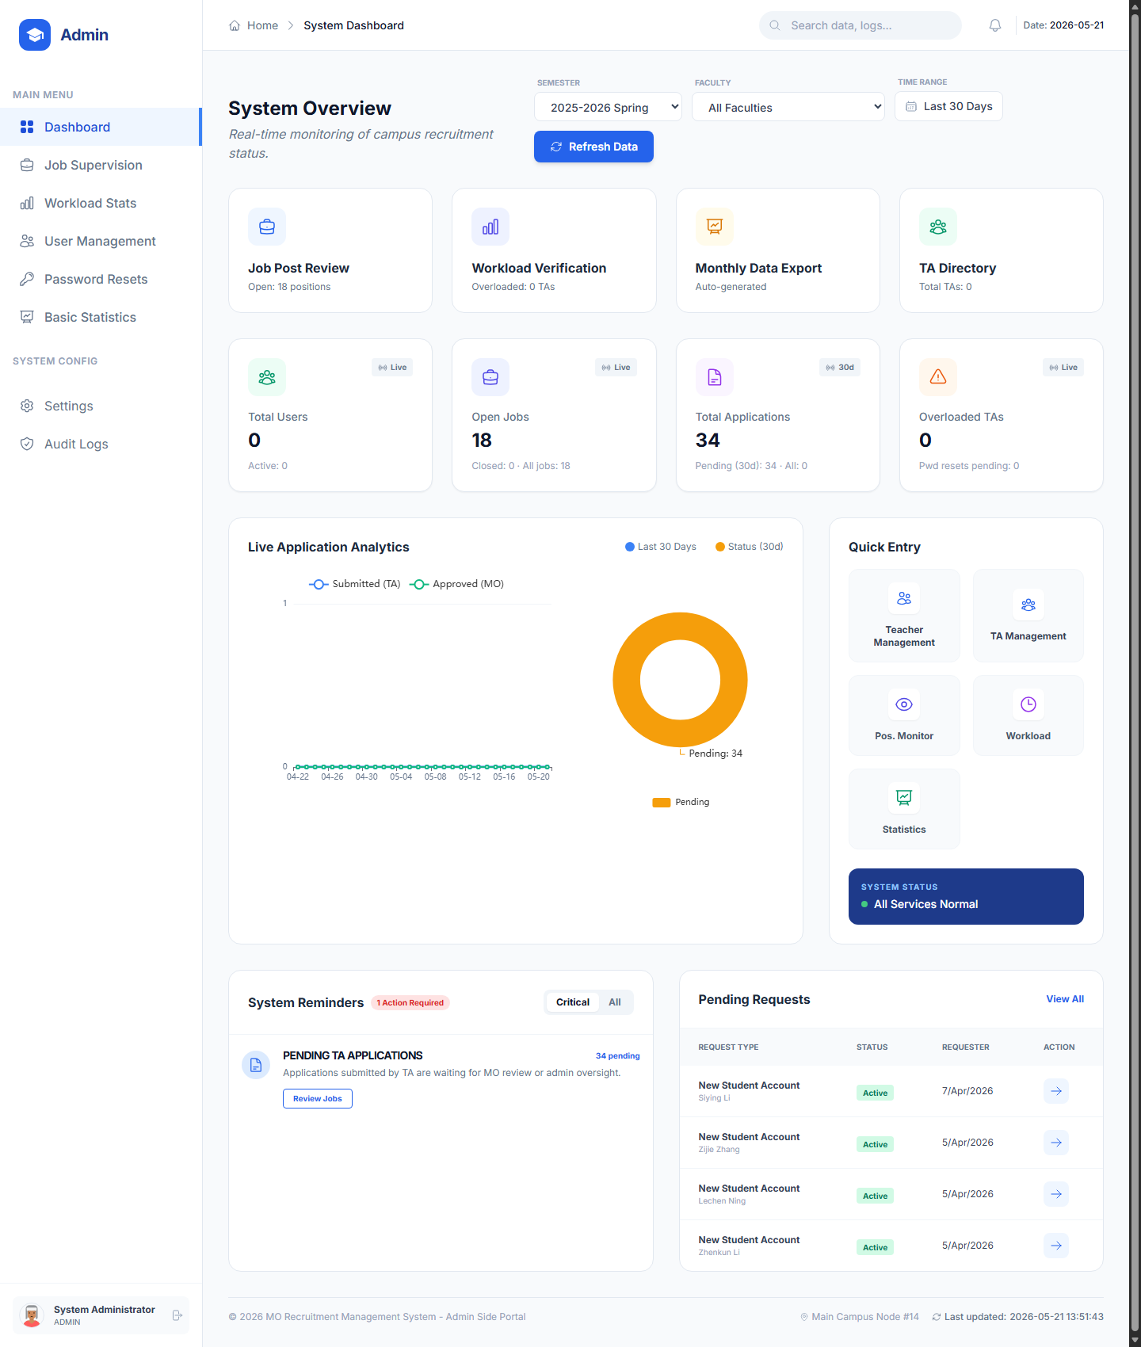  Figure 20. Administrator dashboard providing system-wide overview, alerts, and quick-entry modules. | 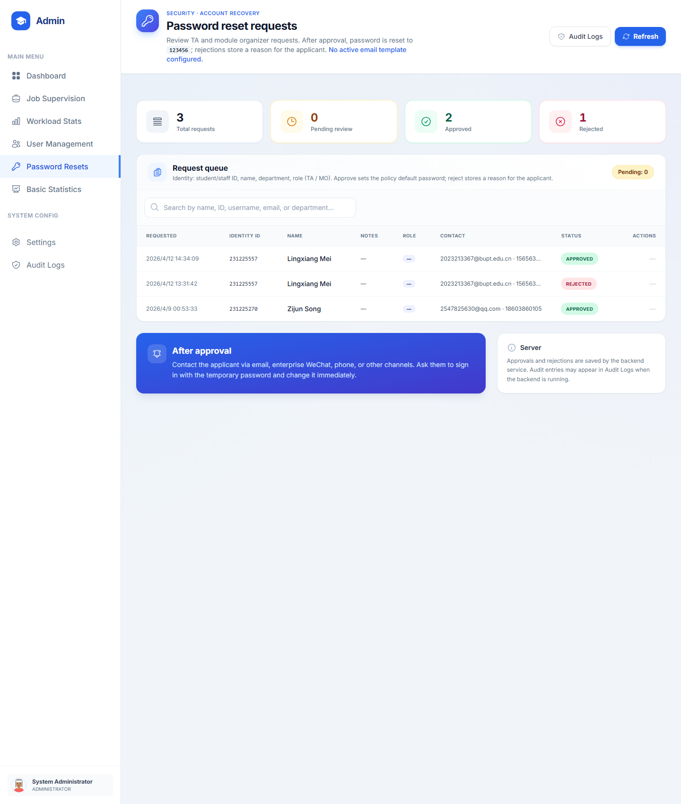  Figure 21. Password reset processing page used by administrators to approve or reject account recovery requests.
These two screens illustrate the most sensitive operational area of the platform. The dashboard aggregates system-wide signals, and the password reset page turns that overview into a concrete account-recovery decision workflow.
Version control and collaboration
Git supported collaboration, change traceability, and release comparison throughout the project. Because the codebase is already separated into frontend folders, backend handlers, models, services, and tests, team members could work on different slices of the system with relatively low conflict risk. Commits were linked to identifiable user-story increments such as draft recovery, upload validation, password reset processing, UI improvements, and statistics pages. Version control also helped the group compare intermediate versions, keep a recoverable baseline, and organise the move from an earlier test version to the more complete current build reflected in the user manual.
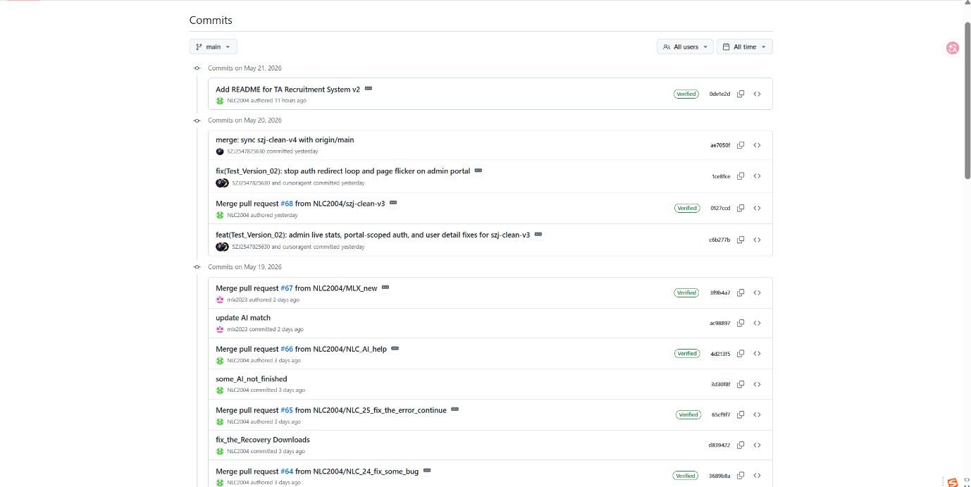Figure 22. Git version history showing iterative development and refinement of the project.
The version-history evidence reinforces the collaboration discussion by showing that refinement happened iteratively rather than in one final merge step.

Testing
Unit testing
We conducted unit testing by simulating three distinct roles—instructor, teaching assistant, and administrator—across the system’s core modules. Each role was assigned a dedicated test account to verify that permissions, workflows, and interfaces behave as expected. For instructors, we focused on creating TA positions, setting deadlines, and reviewing applicants. For TAs, we tested application submission, document uploads, and viewing assignment status. For administrators, we validated notification broadcasting, quota management, and overall dashboard statistics. By isolating each module (e.g., job creation, application list, profile updates) and executing role-specific operations, we uncovered several edge cases: a TA could accidentally edit a submitted application before the deadline; an instructor saw pending counts that did not refresh in real time; and an admin’s quota change failed to trigger a warning when overbooked. These unit tests confirmed that while basic CRUD functions worked, cross-role data synchronization and real-time updates needed refinement. This role-based simulation approach proved efficient—it allowed us to catch permission leaks and workflow gaps early, ensuring that the final interface remains both secure and user-friendly for all stakeholders.

The use of Generative AI (GenAI)
During the frontend and backend development, we leveraged GenAI to assist with fixing bugs in the code and providing good solutions to practical coding problems. Additionally, since we hadn't yet learned some of the web development techniques, we also used AI to aid us in the development process.

Individual contribution and reflection
QM no: 231225339
Name: Lechen Ning
Main contribution: Take the whole situation into account and plan accordingly, as well as MO portal frontend and backend, including forgot-password.html, index.html, personal-center.html, ExportTask.java, Job.java, Notification.java, DataService.java, MailService.java
Reflective statement: Learned holistic project planning and full-stack integration. Overcame mail service and export task challenges. Improved backend-frontend coordination.

QM no: 231225557
Name: Lingxiang Mei
Main contribution: TA portal frontend and backend, including application-review-detail.html, application-success.html, dashboard.html, forgot-password.html, index.html, my-ta-applications.html, AuthHandler.java, ApplicationHandler.java, JobHandler.java, UploadHandler.java,
Reflective statement: Mastered TA portal development and authentication workflows. Solved application handling issues. Strengthened Java backend and responsive frontend skills.

QM no: 231225672
Name: Siying Li
Main contribution: TA portal frontend and unit testing, including notifications.html, personal-information.html, ta-recruitment-application-form.html, ta-recruitment-detail.html, ta-recruitment-list.html and all the unit testing examples in the unit_testing folder.
Reflective statement: Gained expertise in TA portal UI design and unit testing. Tackled edge cases and form validation. Developed strong frontend and JUnit testing abilities.

QM no: 231225270
Name: Zijun Song
Main contribution: Admin portal frontend and backend, including audit-logs.html, basic-statistics.html, index.html, password-reset-requests.html, system-settings.html, user-detail.html, user-management.html, AdminHandler.java, DraftHandler.java, NotificationHandler.java, StaticHandler.java, AIMatchingService.java,
Reflective statement: Learned admin portal features including AI matching and audit logs. Faced statistics and security challenges. Enhanced backend logic and system monitoring skills.

QM no: 231225731
Name: Zijie Zhang
Main contribution: Admin portal frontend and backend, including admin-dashboard.html, job-supervision.html, workload-overview.html, AdminRoleTemplate.java, Application.java, User.java
Reflective statement: Understood role-based access and workload management. Overcame database integration for user applications. Improved Java OOP and data modeling skills.

QM no: 231225649
Name: Zhenkun Li
Main contribution: MO portal frontend and backend, including job-create.html, job-detail.html, jot-edit.html, my-job-list.html, notification-messages.html, PassowrdResetRequest.java, AuditLog.java
Reflective statement: Developed MO portal job management and audit logging. Solved password reset and notification bugs. Improved full-stack development and error handling.

